François HOLLANDE and Valérie TRIERVEILLER
The separation .

François Hollande, the French president and Valerie Trierveiller, his ex-fiancé, lived in the same house .They wanted to marry.

One day the president said in front of a lot of people that he never wanted to see Valerie Trierveiller anymore.

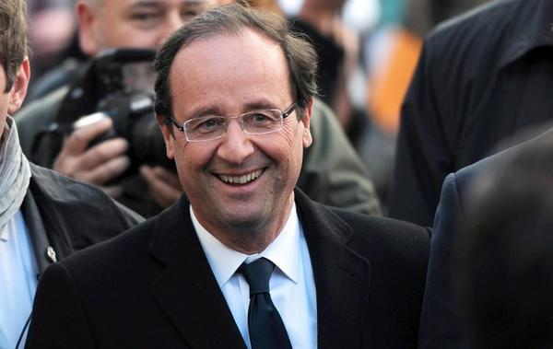
Vallerie trierveiller said she was going to be fine in front of an assembly.

They separated in front of France and in front of the media and we know the president is alone and we wonder if he has a new friend.

Kylian ; Clément ; Corentin 5e2

